**IMAGE RESTORATION**

**Perform restoration using filter:**

i=imread('flr1.jpg');

j=rgb2gray(i);

f=imnoise(j,'Salt & Pepper');

g=filter2(fspecial('average',3),f)/255;

g1=ordfilt2(f,median(1:3*3),ones(3,3));

subplot(2,2,1);

imshow(i);

title('Original Image');

subplot(2,2,2);

imshow(f);

title('Noise Image');

subplot(2,2,3);

imshow(g);

title('Average Filter');

subplot(2,2,4);

imshow(g1);

title('Median Filter');

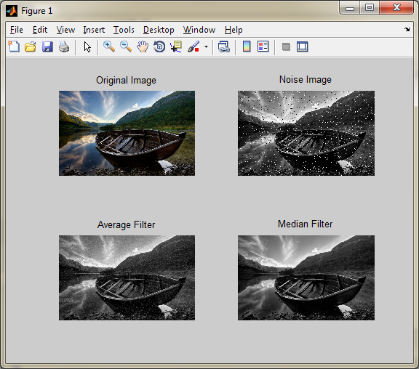

**Perform wiener filter:**

**Blurring an image:**

LEN = 31;

THETA = 11;

PSF = fspecial('motion',LEN,THETA);

Blurred = imfilter(i,PSF,'circular','conv');

figure; imshow(Blurred);title('Blurred Image');

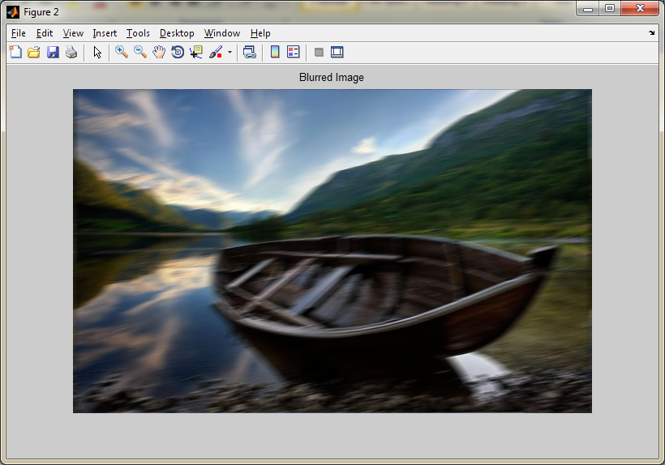

**Deblur the image:**

wnr1 = deconvwnr(Blurred,PSF,0.0001);

figure;imshow(wnr1);

title('Restored, True PSF');

